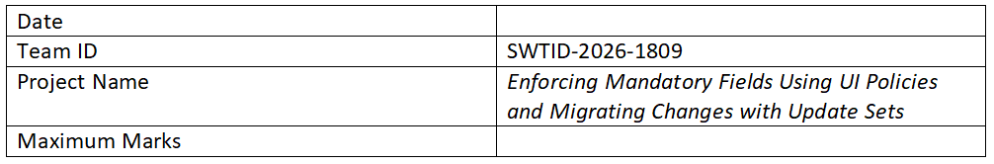

Proposed Solution Template
Date: 15 February 2025
Project Title: Implementing Mandatory Field Validation Using UI Policies and Migrating Changes Through Update Sets

S.No. | Parameter | Description
1 | Problem Statement (Problem to be solved) | In many systems, important fields are often left empty, leading to incomplete data and errors. Additionally, managing and migrating system changes manually can cause inconsistencies.
2 | Idea / Solution Description | This project uses UI Policies to enforce mandatory fields dynamically based on conditions. Update Sets are used to capture and migrate changes efficiently between environments.
3 | Novelty / Uniqueness | The solution minimizes manual validation and automates both field enforcement and change migration, ensuring accuracy and consistency.
4 | Social Impact / Customer Satisfaction | Improves data accuracy and user experience by preventing incomplete submissions, leading to better service quality.
5 | Business Model (Revenue Model) | Can be implemented in enterprise systems to improve workflow efficiency, reducing operational costs and errors.
6 | Scalability of the Solution | The solution can be scaled across multiple modules and systems, as UI Policies and Update Sets can be reused and extended easily.

